Creating a World of Play: What Children Are Learning

The purpose of the preschool program is to give the children the opportunity to grow emotionally, physically, intellectually, and socially. Throughout each day, we will be guiding your child into choosing and participating in a variety of activities. Intentionally organized learning experiences are planned for the children that will build self-esteem, challenge your child’s thinking and reasoning skills, encourage healthy relationships with peers and the staff, and explore various curriculum topics. Your children will spend time in self chosen learning centers that include blocks, dramatic play, math and manipulatives, art, discovery, computers, sand and water table (sensory), and literacy centers.

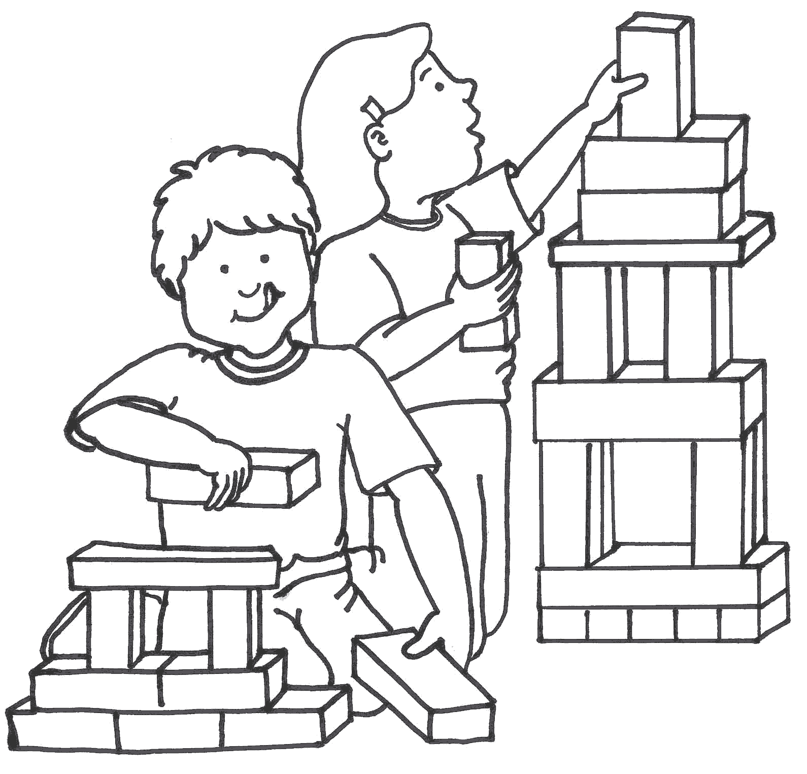
Blocks
- Interacting with Spatial Relationships
- Discriminating and Classifying Shape, Size and Color
- Experimenting with balance and form
- Gaining Knowledge of Cause and Effect
- Cooperating
- Balance and Hand Eye Coordination
- Organization and Sequential Skills
- Enhancing Problem Solving, Design, and Construction Skills
- Recognizing quantity and number concepts

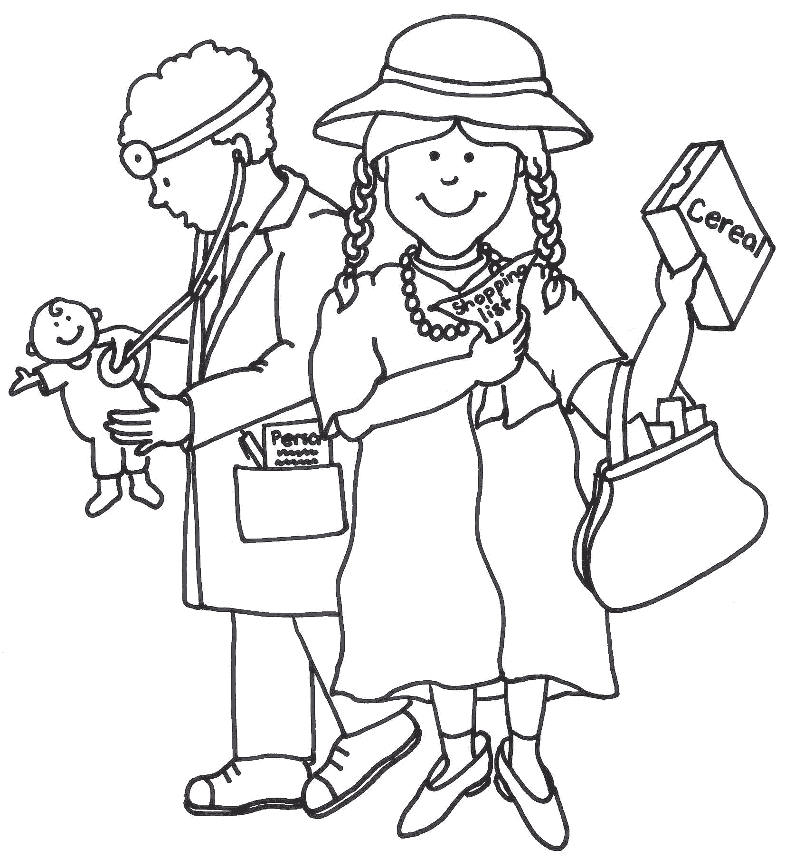
Dramatic Play
- Learning Conflict Resolution Skills (Bringing the Adult World Down to Size)
- Increasing Verbal Skills and Language Development
- Cooperating
- Expressing Self Creatively and Individually
- Making Choices and Plans
- Understanding and Expressing Feelings
- Enhancing Observation Skills
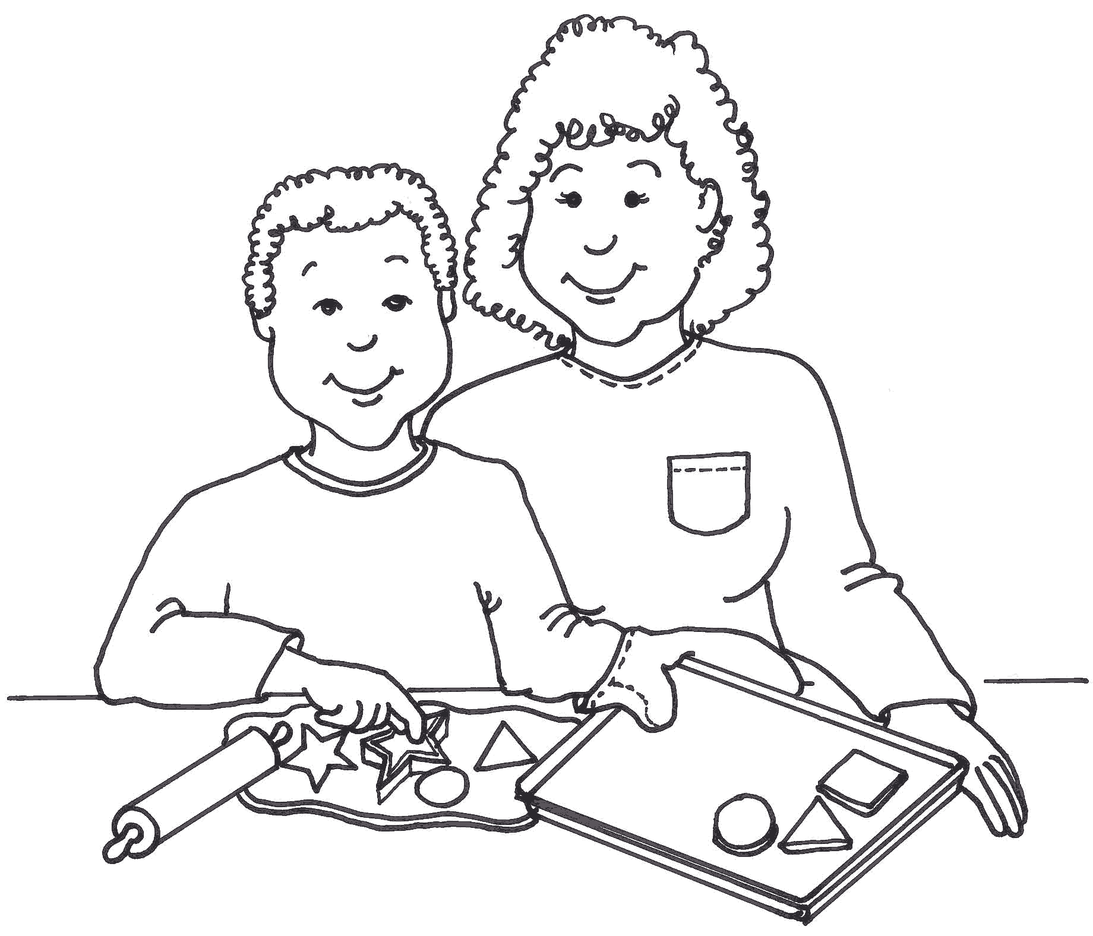
Math and Manipulatives
- Developing Perseverance and Self-Control
- Increasing Visual Discrimination Skills
- Enhancing Hand –Eye Coordination
- Experimenting with Tactile Discrimination
- Learning Distance and Directionality
- Toning Manipulative and Fine Motor Skills
- Developing Math Skills (estimation, sequencing, classifying, sorting, counting, comparing, patterns, and shapes)
- Focusing on Spatial Concepts

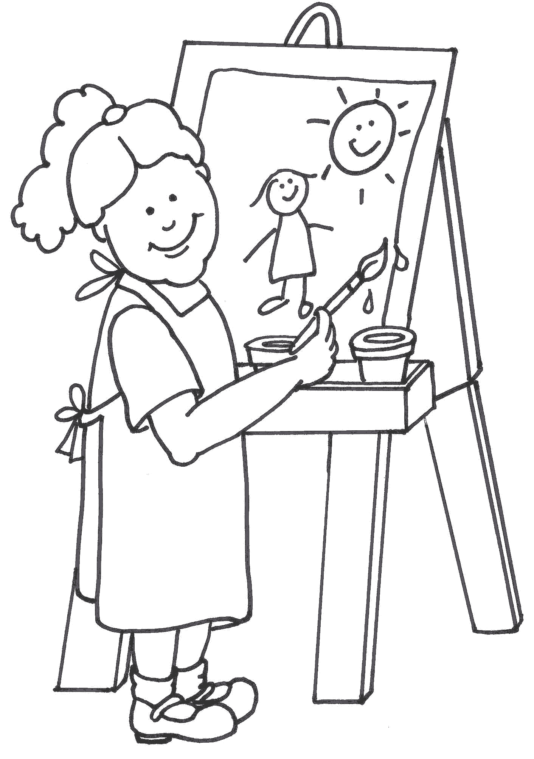
Art
- Exercising Fine Motor Skills
- Expanding Creative Representation
- Experimenting with Color, Shape, and Size Relationships
- Achieving Individual Expression
- Understanding Symbols
- Bringing Ideas to Life
- Increasing Language Development
- Enhancing Eye-Hand Coordination

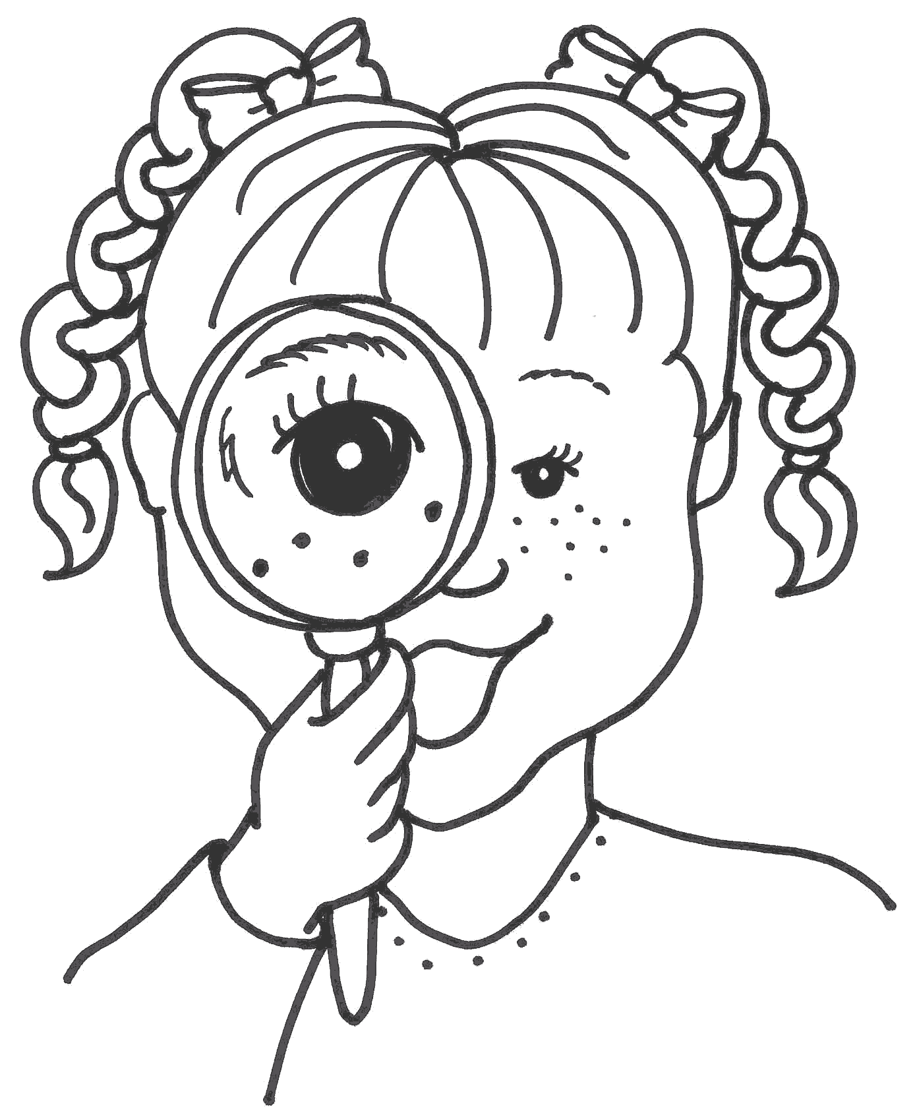
Discovery
- Drawing Conclusions and Making Predictions
- Learning and Testing New Concepts
- Learning to Plan and Discover
- Understanding Change and the Natural World
- Gaining Knowledge of Cause and Effect
- Identifying Living and Non-living Things
- Experimenting, Discovering and Refining Observation Skills

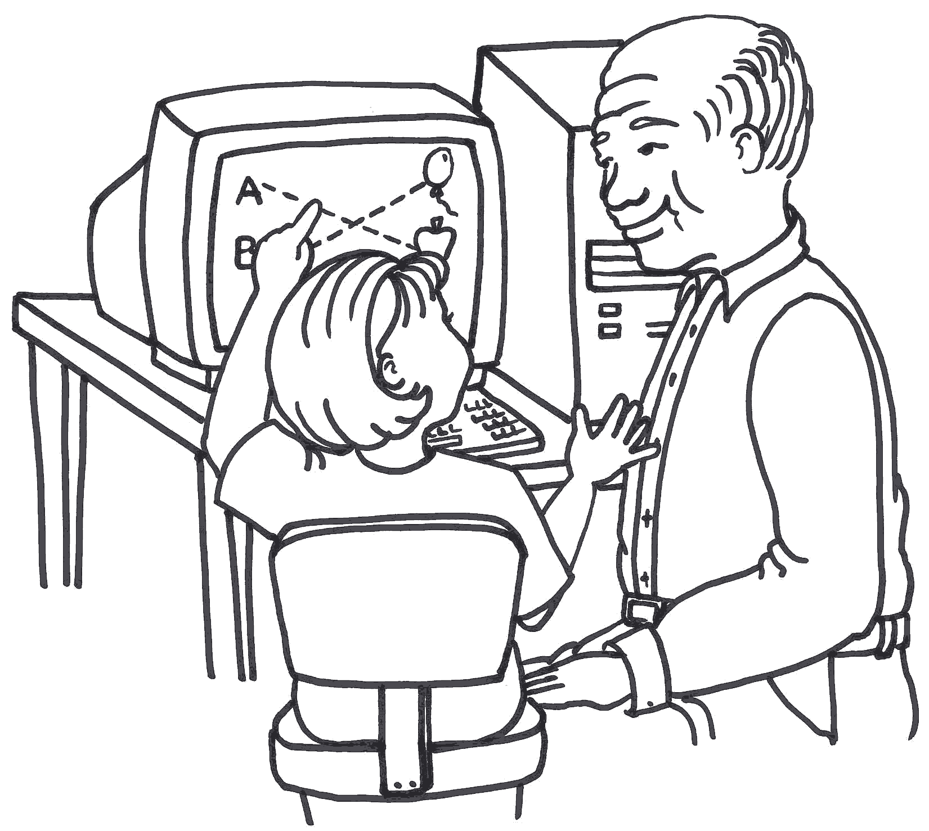
Computers
- Developing Logic and Reasoning
- Enhancing Hand Eye Coordination/Fine Motor Skills
- Experimenting with Technology
- Gaining Knowledge of Cause and Effect
- Classification and Mathematical Reasoning
- Enhancing and Advancing pre-writing skills

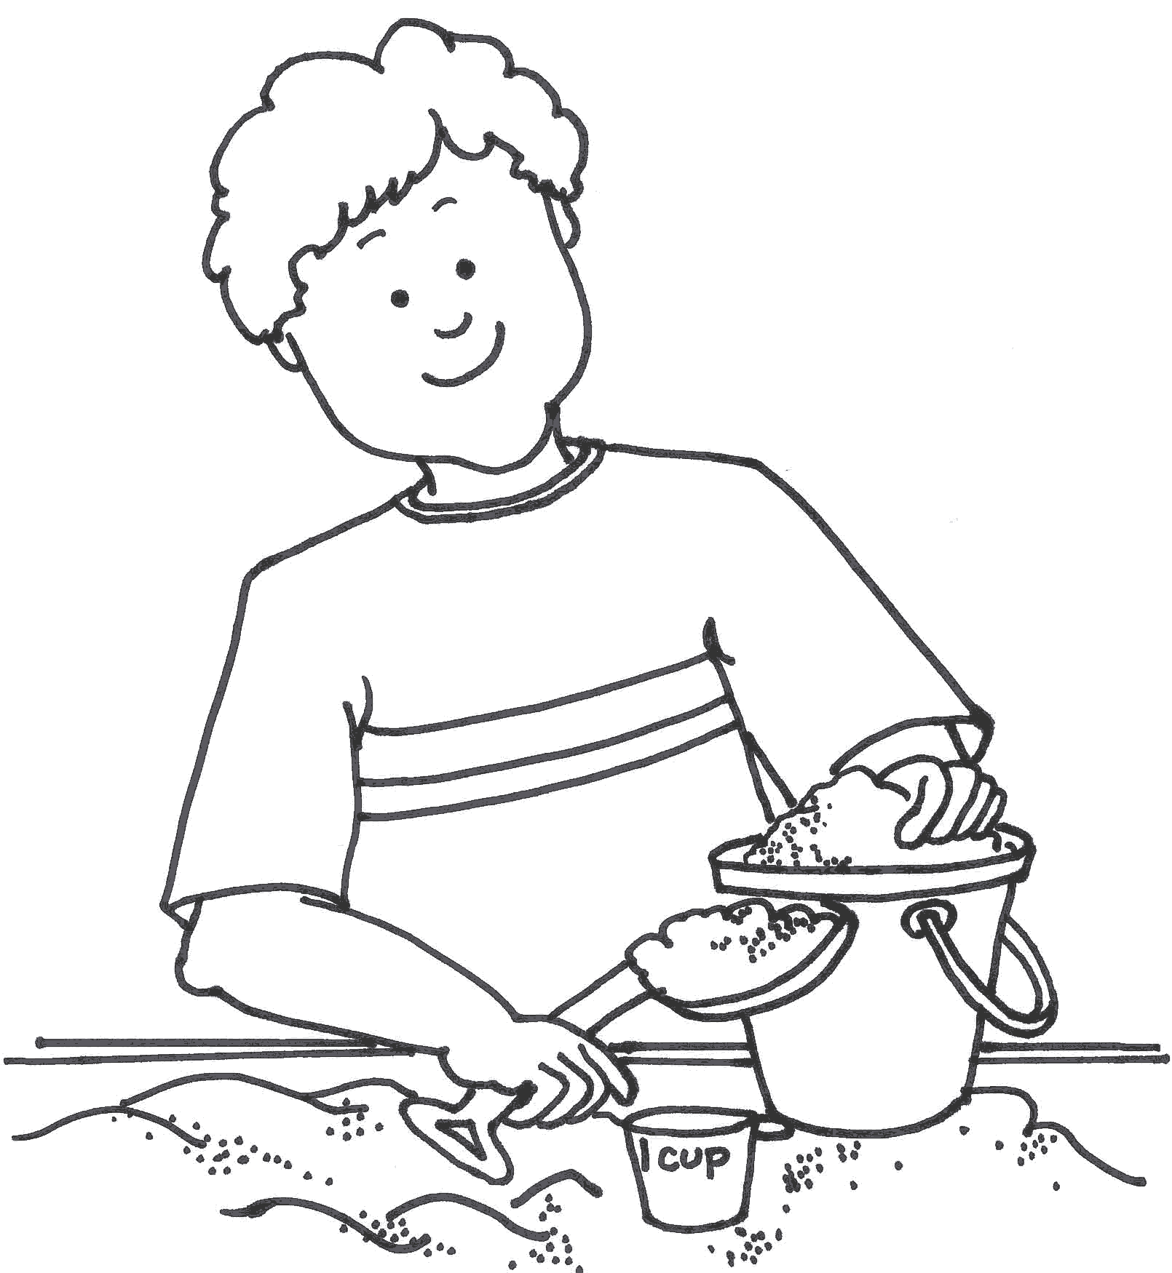

Sand and Water Table
- Focusing on Sensory Exploration and Discovery
- Experimenting, Discovering and Refining Observation Skills
- Learning about Measuring and Weighing
- Refining Problem Solving Skills
- Gaining Knowledge of Cause and Effect
- Experimenting with Properties of Matter and Conservation of Matter

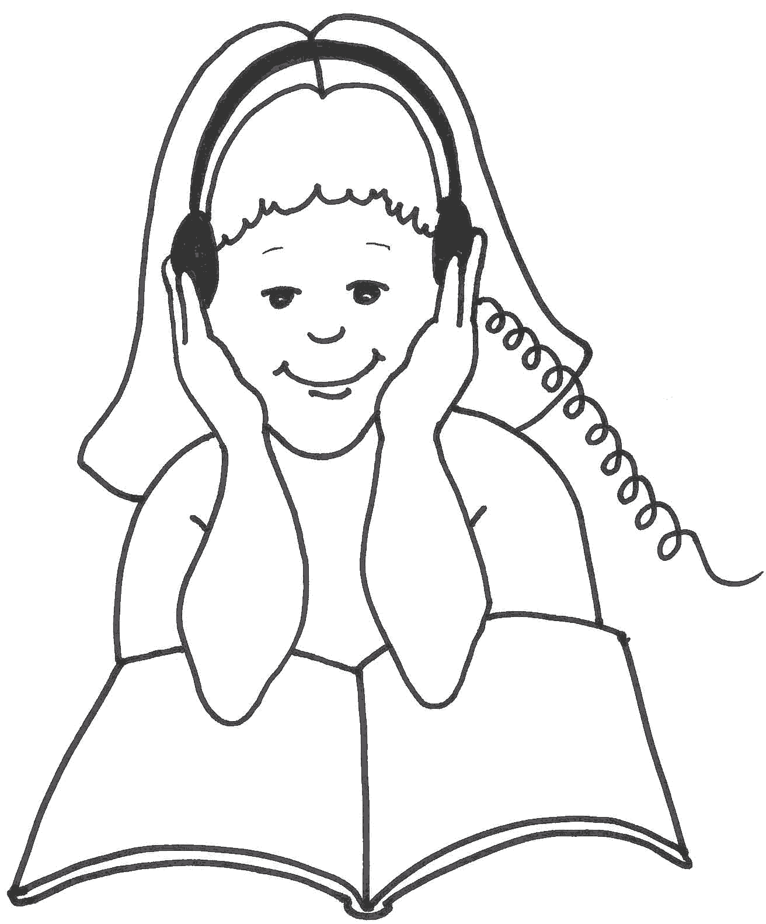
Literacy Center
(includes library, listening, and writing)
- Increasing Language Development
- Developing Comprehension Skills
- Learning pre-reading Skills
- Sequencing and Story Telling
- Learning Concepts About Print
- Using and Refining Fine Motor Skills
- Using Print to Convey Meaning
- Experiencing Quiet Moments
- Working Independently
- Developing a Love For Books

