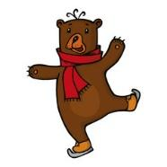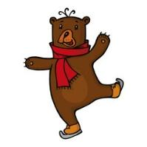

**BELLEVUE ELEMENTARY SKATE NIGHT**

Calling all Bellevue Bears!!!

Please come and join the fun for some

***FREE ICE SKATING***

**WHEN:**Friday, September 30th

5:30pm – 7:30pm

**WHERE:**

The Campion Ice House

Hailey, Idaho

**WHAT:**

Ice Skating

Skate rentals are available on a first come basis!

**YOUR JOB:**

Wear warm clothes

And most importantly… HAVE THE MOST FUN POSSIBLE!

**A HUGE thank you to Campion Ice House to allow us to use the rink.**



For more information: Emily Thomson 208.309.2844

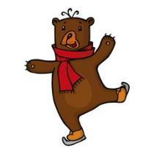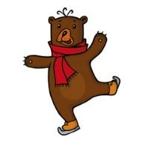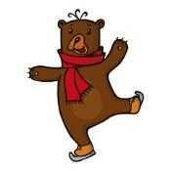

NOCHE DE PATINAJE FAMILIAR

llamando a todos los osos de la primaria de Bellevue!!

¡Vengan a divertirse!

**Cuando:** Viernes 30 de September

**Hora:** 5:30pm-7:30pm

**Donde:** Campion Ice House en Hailey

**Qué:** Patinaje gratis

Patines estarán disponible a primera llegada de solicitudes

¡Póngase ropa calentita y nos vemos ahí!

Un ENORME agradecimiento a Campion Ice House por permitirnos usar la pista.



Para mas informacion: Emily Thomson 208.309.2844