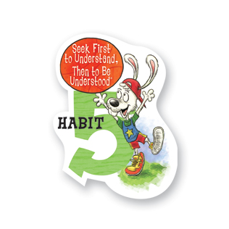
Habit 5: Seek First to Understand, Then to Be Understood Listen Before You Talk
I listen to other people’s ideas and feelings. I try to see things from their viewpoints. I listen to others without interrupting. I am confident in voicing my ideas. I look people in the eyes when having a conversation.
Seek First to Understand, Then to Be Understood means that it is better to listen first and talk second. By taking the time to listen to another person, you reach a higher level of communication. Young children find it difficult to understand another’s paradigm (point of view). This habit is best approached by introducing listening as a skill that should be practiced. Learning to listen without interrupting and learning to listen with your ears, your eyes, and your heart will help children build a foundation for Habit 5. Simply put, we have two ears and one mouth so that we can spend more time listening with the intent to understand. Remember that when listening body language can be just as important as words.

Habit 5: Seek First to Understand, Then to Be Understood Listen Before You Talk
I listen to other people’s ideas and feelings. I try to see things from their viewpoints. I listen to others without interrupting. I am confident in voicing my ideas. I look people in the eyes when having a conversation.
Seek First to Understand, Then to Be Understood means that it is better to listen first and talk second. By taking the time to listen to another person, you reach a higher level of communication. Young children find it difficult to understand another’s paradigm (point of view). This habit is best approached by introducing listening as a skill that should be practiced. Learning to listen without interrupting and learning to listen with your ears, your eyes, and your heart will help children build a foundation for Habit 5. Simply put, we have two ears and one mouth so that we can spend more time listening with the intent to understand. Remember that when listening body language can be just as important as words.

