Concussions: What are they and what can we do about them?

Concussions are common: It is estimated that there are 1.7 to 4 million sport related concussions in the united states per year. The vast majority of these have, until recently, gone unrecognized. Concussions occur in virtually all competitive sports and occur more frequently in younger athletes.
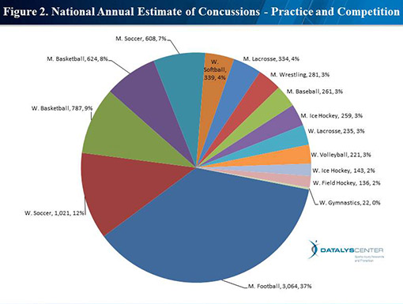
Concussions are most common in middle and high school athletes:
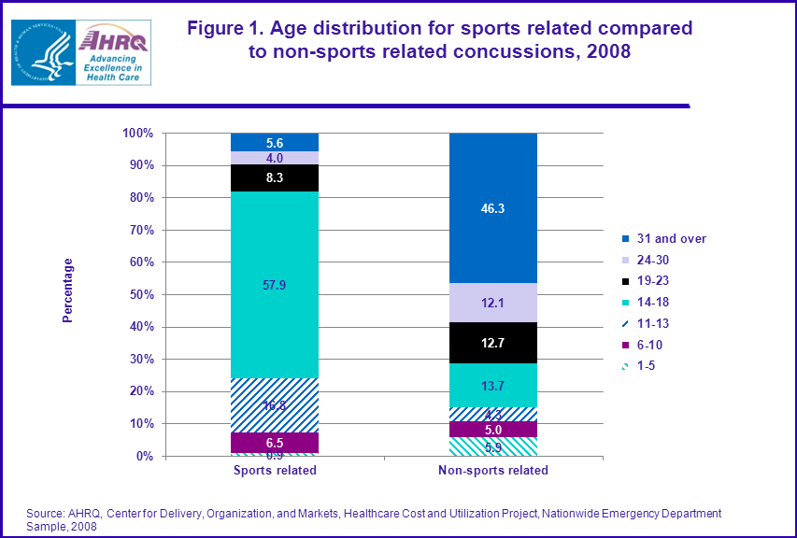

What is a concussion? A concussion is an injury sustained from a rotational acceleration or deceleration injury to the head that causes an alteration of mental status or various other symptoms such as headache or dizziness.

More simply is a trauma-induced alteration in mental status that may or may not involve loss of consciousness.

The precise definition has been debated for some time but on concensus statement is as follows:

- Concussion may be caused by a direct blow to the head, face, neck or elsewhere on the body with an “impulsive” force transmitted to the head.
- Concussion typically results in the rapid onset of short lived impairment of neurologic function that resolves spontaneously.
- Concussion may result in neuropathological changes but the acute clinical symptoms largely reflect a functional disturbance rather than a structural injury.
- Concussion results in a graded set of clinical syndromes that may or may not involve loss of consciousness. Resolution of the clinical symptoms typically follows a sequential course.
- Concussion is typically associated with grossly normal structural neuroimaging studies.

Based on this definition it is clear that diagnosis cannot be obtained simply by CT scans or MRI’s but rather is established through evaluation by a healthcare professional supplemented by appropriate neurocognitive testing.

What is a concussion not: A concussion is not a trivial event to be taken lightly. However, a concussion is NOT a severe traumatic brain injury. By definition a concussion is transient and should resolve relatively rapidly. A traumatic brain injury results in irreparable damage to cells known as neurons in the brain. This damage means that symptoms do not resolve in the typical time frame seen in concussions.

Concussion symptoms: Headache is the most common symptom. Due to the metabolic demands of concussions this often progresses through the day. Up to 25 symptoms have been described and more severely concussed individual. Common symptoms include:
Headache | Nausea/vomiting | Balance Problems
Light/sound sensitivity | Fatigue | Dizziness
Mental fogginess/slowing | Difficulty concentrating | Forgetfulness
Irritability | Sadness | Anxiety
Sleeping more/less | Trouble falling asleep | Drowsiness

Concussions are heterogeneous: There are four primary domains that we see effected in concussions. These include cognitive function, sleep, mood domains and migraine type symptoms. A concussion may affect any of these domains in equal or unequal proportions. We cannot rule out concussion because any one domain is absent or present.

The second hit problem: Concussions result in metabolic injury to the brain. While the brain is using excess energy to repair damaged circuits other areas of the brain are more susceptible to injury. Risk of a second concussion is greatest during the first 10 days after a concussive event.

Concussions are treatable: Treatment is two-fold. First treatment involves removal from competition to protect athletes from the second hit and ensure faster recovery. More importantly treatment can be tailored to the particular concussion type ensuring more rapid recovery. Treatment includes a graded return to activity. It does not involve complete absence of activity. The key is supervised activity guided by symptoms. Evidence is showing that graded return to activity decreases the anxiety component of concussions and may decrease overall morbidity. Physical therapy aides in re-establishing ocular tracking and in re-training the vestibular system. This may result in fewer subsequent injuries which may be postulated to be due to poor balance or response times.

To treat concussions we must recognize them: While some individuals may have a clear concussion on initial evaluation others are more insidious. We can evaluate your vision, balance and symptoms on the sidelines however evaluation of cognition, reaction speed and decision making are more difficult. Therefore we have the ImPACT test to help better delineate benign blows from concussive events.

The ImPACT test: ImPACT testing acts as stress testing for the brain. We would test your heart on a treadmill because its function is to provide oxygen to the body. We test your brain with intellectual challenges which challenge its’ ability to deal with increased metabolic demands. The ImPACT test therefore acts as a 20 minute stress test for the brain. Specifically it focuses on:
- Attention span
- Working memory
- Sustained and selective attention span
- Response variability
- Non-verbal problem solving
- Reaction time
- Impulse control

The importance of pre-testing: Your baseline cognitive function is not my baseline. Your baseline is not that of your peers and in fact it is not even that of yourself from two years ago. As the brain grows through adolescence executive function, memory and reaction times change. Therefore, for a post event test to have clinical significance we need an accurate baseline test to compare it with. ImPACT testing for young athletes should begin at age 10 and should be repeated every two years until completion of high school. Having this baseline allows us to accurately determine if a concussion has occurred and to guide post-concussive care with appropriate return to activity when symptoms have adequately resolved.

Concussion care in action: Baseline testing should occur PRIOR to the athlete’s season. Once a concussion is suspected a post-injury test should be administered within 24-72 hours of the event. Results should be reviewed with a physician experienced in the care of concussions. Care should be coordinated with the physician, physical therapy, athletic trainers, coaches and parents to ensure safe return to activity in a timely manner.
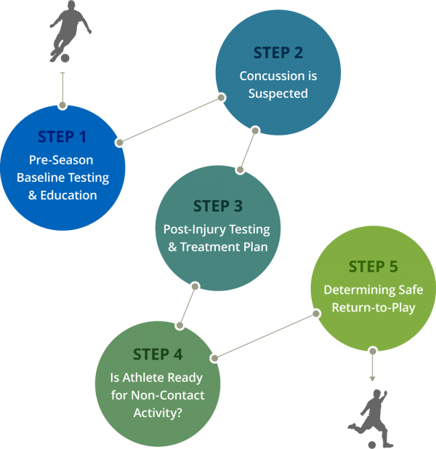

When am I cleared for return to activity: Athletes may return to competition when:
- They are symptom free with physical and cognitive exertion
- Their ImPACT test has returned to baseline
- They have a normal vestibular and ocular exam

What do I do if I suspect my child has suffered a concussion?
Repeat ImPACT testing should be completed within 24 – 72 hours of an incident. Follow-up should be done with a concussion expert. In the Wood River Valley care should be coordinated with Dr. Frank Batcha and St. Luke’s physical therapy. Call physical therapy 1st for an ImPACT test appointment. Then call Dr. Batcha’s office for the next available appointment following testing.
1st Appointment: repeat ImPACT testing: | 2nd Appointment: review testing and plan treatment:
St. Luke’s Physical Therapy | Dr. Frank Batcha
(208) 727-8281 | (208) 622-8811

